## OIPGJW8KARD **The Sin Problem**

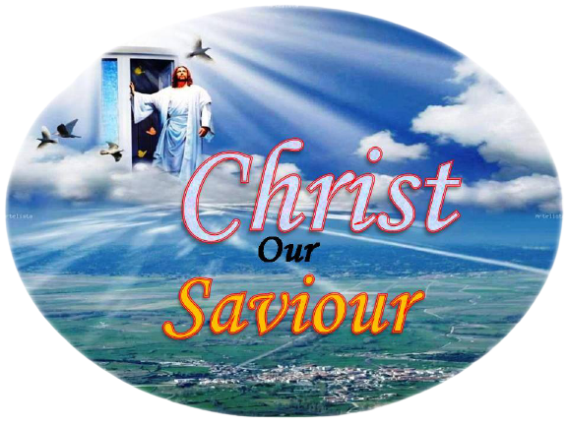

Spring of Life Mission outreach Ministries

***Lesson 1***

## **The Sin Problem**

1. **To whom did God give the dominion of this world?** Gen. 1 : 26-28.

2. **Whom did man in turn give the dominion of this world to?** Gen. 3 : 1-7; Luke 4:5,6

3. **Who has been the prince or god of this world since the fall of man?** John 14 :30; 2 Cor. 4:3,4

4. **Who alone is not under the control of Satan in this world?** John 5: 19

Only the true Christian is not under the control of Satan.

5. **What is the relationship between Satan and the natural man?**

2 Peter 2: 19; Rom. 6 : 17

A slave has no choice but to do the biddings of his master



***Introduction:*** Sin is responsible for all the suffering, woe and death we are experiencing in this world. Without knowing what sin is, and how deep-rooted it is in every human being, we cannot appreciate the solution God has provided for it. “Sin is the transgression of the law” (1John 3:4).

1***. In whom did sin originate? Ezekiel 28: 14,15***

***2. How did sin manifest itself in Satan. Isaiah 14: 12-14***

From this, we see that SELF-CENTREDNESS is the essence of sin. Sin therefore, is the opposite of the nature of God, which is love (see 1John 4:8). God’s love is defined as self-forgetting concern for the well-being of others (see Philippians 2: 5-8).

3. ***At the height of his sin, what did Satan plan to do to God? John 8: 44***

From the beginning here refers to the time Lucifer became a sinner. He wished then to eliminate God so that he could enthrone himself.

***4 As a result of Satan’s ambition to be like God, what happened in heaven? Rev. 12:7-9***

***5. How many angels fell with Satan? Rev.12: 4***

One-third of the heavenly angels fell with him. Since there are billions of angels, the angels following Satan are quite a lot – but they are less in number than the good angels. Demonic activities in our world are due to satanic angels.

***Sin on the Planets Earth***

1. **To whom did God give the dominion of this world?** Gen. 1 : 26-28.

2. **Whom did man in turn give the dominion of this world to?** Gen. 3 : 1-7; Luke 4:5,6

3. **Who has been the prince or god of this world since the fall of man?** John 14 :30; 2 Cor. 4:3,4

4. **Who alone is not under the control of Satan in this world?** John 5: 19

Only the true Christian is not under the control of Satan.

5. **What is the relationship between Satan and the natural man?** 2 Peter 2: 19; Rom. 6 : 17

A slave has no choice but to do the biddings of his master

POWER OF SIN

## **Sin on the Planet Earth**

## **Sin on the Planet Earth**

## **Sin on the Planet Earth**

## **Sin on the Planet Earth**

## **Sin on the Planet Earth**

1. ***At what stage does a human being become a sinner*?** Psalm 51: 5

In the King James Version, the text reads “Behold I was shapen in iniquity: and in sin did my mother conceive me.” The root meaning of the word translated “Iniquity is to be bent: “David recognized that children inherit natures with propensities to evil.” *SDA Bible Commentary* Vol. 3, page 755. We are born in a state of alienation from God.

1. ***Since human beings are born sinners, is it possible for them to do any good in their human power?*** Jer. 13: 23

2. ***But some people who are not true Christians perform good acts. Can Jer. 13:23 really be true?*** Isaiah 64: 6

Since man is born self-centered, even the good he does is tainted with self-interest. No matter how great a good deed is, if it is motivated even in a remote way by self-interest, God regards it as a filthy rag! “All that men can do without Christ is polluted with selfishness and sin.” Ellen G. White, *Selected Messages,* Book 1, page 364.

3. ***How does the Bible further confirm this*** fact? 1 Cor. 13: 1 – 3 : Rom. 14: 23

Any good deed we do that is not a result of our faith relationship with Christ is sin. “Education, culture, the exercise of the will, human effort. . . may produce and outward correctness of behavior, but they cannot change the heart; they cannot purify the springs of life.” Ellen G. White, *Steps to Christ*, page 18.

4. ***How does the Bible define sin in terms of God’s righteousness? Rom. 3: 23***

This means any one whose righteousness falls short of God’s righteousness – no matter by what degree - is a sinner. And no righteousness which is less than God’s righteousness saves anybody. For anybody to be saved he must have a perfect righteousness.

Ellen G. White says: “The condition of eternal life is now just what it always has been,-just what it was in Paradise before the fall of our parents, – perfect obedience to the law of God, perfect righteousness. If eternal life were granted on any condition short of this, then the happiness of the whole universe would be imperiled.” Ellen G. White, *Steps to Christ* page, 62.

She states man’s problems when she says, “It was possible for Adam, before the fall, to form a righteous character by obedience to God’s law. But he failed to do this, and because of his sin our natures are fallen and we cannot make ourselves righteous. Since we are sinful, unholy, we cannot perfectly obey the holy law. We have no righteousness of our own with which to meet the claims of the law of God.” Ibid.

***5. In view of the above fact what does the Bible say about all human beings?*** Romans 3: 10

***Conclusion:***

Sin originated with Satan. The essence of sin is self-centredness. Since the fall of Adam, every human being is born self-centred. Hence even the good any person does in his own power is motivated by self-interest. This self-interest-motivated good deeds constitutes man’s righteousness. It is the best he can produce. And God calls it filthy rag. Yet without righteousness as perfect as that of God, nobody can be saved.

***Prayer:***

Lord, please give me the ability to see myself the way you see me, so that I can appreciate your solution to the sin problem. In Jesus’ name, amen.